Team members:

Sriram Vellangallor Subramanian 1209270383

Karumpudi Ramakrishna Reddy 1209319770

Dhiraj Gurkhe 1209305002

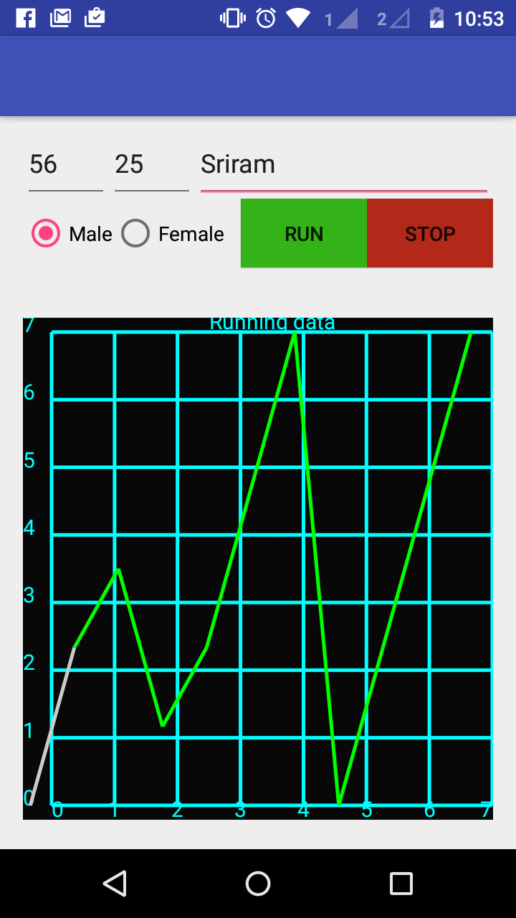

Figure Screenshot